Open Source Graphics And Animation tools
Mid Semester Examination
Phase 1
Anime Cartoon Poster

Submitted to
Dr. Durgansh Sharma
Associate Professor, Cybernetics SCS, UPES

Submitted By

Name: Aayush Mishra
Roll No: 01
SAP ID: 500069632
Submit Date: 5/03/2020

B. Tech CSE (OSSOS)
Department of Cybernetics
COMPUTER SCIENCE & ENGINEERING

School of Computer Science
University of Petroleum and Energy Studies

Table of Contents
LAYER 1-: 3
LAYER 2:- 3
LAYER 3:- 4
LAYER 4:- 5
LAYER 5-: 6
LAYER 6-: 7
BACKGROUND Layer-: 8
Final Poster:- 10
Explanation for Artistic Choices:- 10
References 12

Table of Figures
Figure 1: Layer 1- Detective Conan 3
Figure 2: Layer 2- One Punch Man 4
Figure 3: Text Layer 1- Display Name 5
Figure 4: Text Layer 2- Tag Line 6
Figure 5: Bow Layer 7
Figure 6: Punch Layer 8
Figure 7: Background Layer 9
Figure 8: Final xcf 9
Figure 9: Final .png 10
Figure 10: Poster without Red Channel 11
Figure 11: Poster without Green Channel 11
Figure 12: Poster without Blue Channel 12

The steps to create the Anime Cartoon Poster are as follows:-

LAYER 1-:
- Open GIMP and using File→Open→”Reference Image 1”, to open the first reference image.
- Select Image→Guides→New Guide(by percentage) twice to place a horizontal and vertical guides.
- Right-click on the Layer Toolbar to big up the Layer Toolbar list then “New Layer”.
- In the Layer Attribute Section select the layer to be transparent and name it fig1outline.
- Select “fig1outline” layer and place it above the “Reference Image 1” layer and select the Pencil tool from the Toolbar.
- Start drawing using the reference images.
- Now using the Bucket fill tool and reference image color every the parts of the outline image.

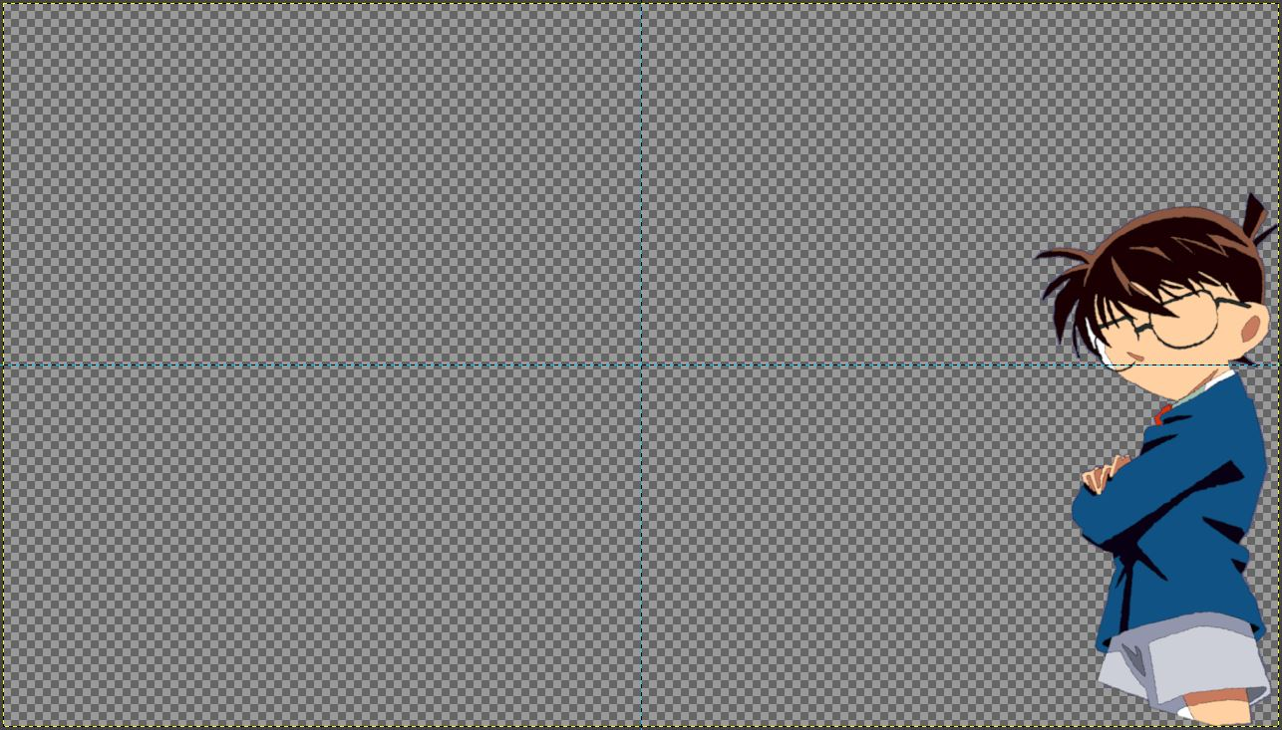Figure 1: Layer 1- Detective Conan

LAYER 2:-
- Again using the Layer Toolbar create another transparent layer.
- File→Open→”Reference Images 2”.
- Again using Pencil tool and using the reference images draw the second anime character.
- Using the Bucket fill tool fill the colors in the second layer.
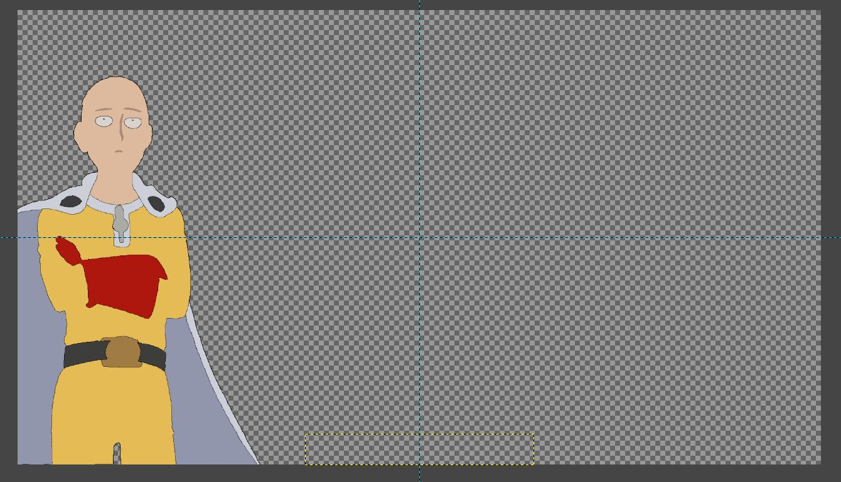Figure 2: Layer 2- One Punch Man

LAYER 3:-
- Select the Text tool from the toolbar option.
- In the Font toolbar that appears set the following values:-
  - Hinting → “Full”.
  - Alignment → “Centered”.
  - Color → “c4c4c4” (hex value).
  - Indentation of the first line → “0.0”px.
  - Line Spacing → “3.0”px.
  - Letter Spacing → “3.0”px.
  - Kerning → “0.0”px (default).
  - Font → Chinese Asian Style (external font) (refer to References).
  - Size → “120px”.
  - Bold On.
- Type “DETECTIVE CONAN <next line> One Punch Man”.
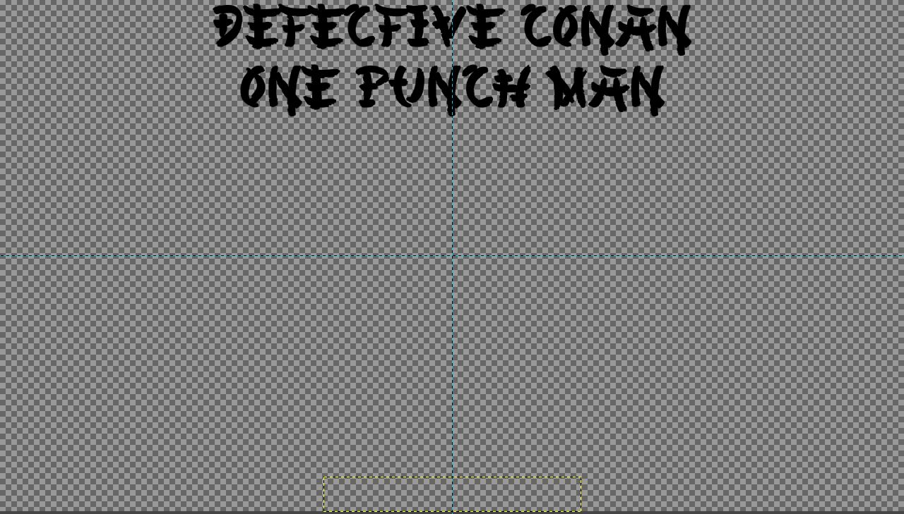Figure 3: Text Layer 1- Display Name

LAYER 4:-
- Again using the Text toolbar.
- Setting the option in the font toolbar.
  - Hinting → “Full”.
  - Alignment → “Centered”.
  - Color → “c4c4c4” (hex value).
  - Indentation of the first line → “0.0px”.
  - Line Spacing → “3.0px”.
  - Letter Spacing → “3.0px”.
  - Kerning → “0.0px”(default).
  - Font → Chinese Asian Style (external font) (refer to References).
  - Size → “70px”.
  - Bold Off.
- Type “EPIC CROSSOVER”.
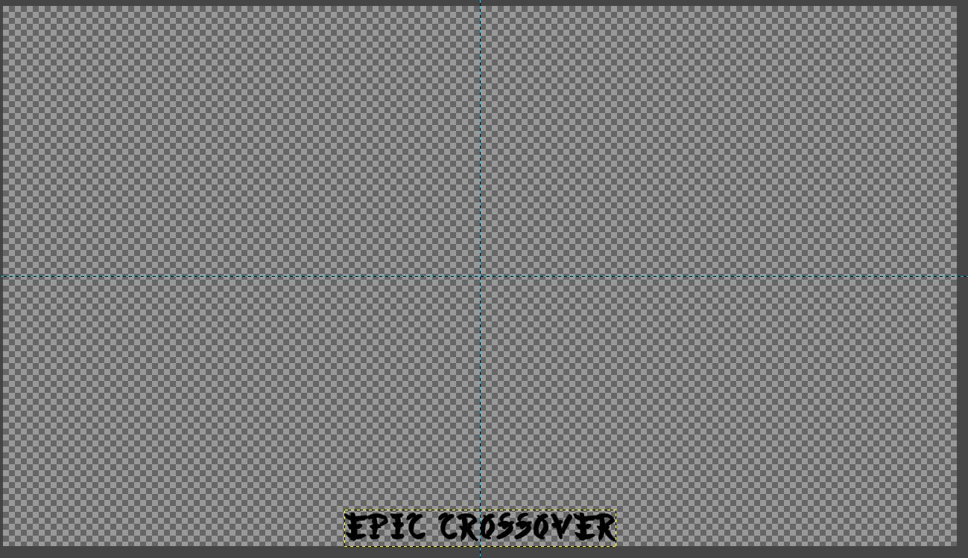Figure 4: Text Layer 2- Tag Line

LAYER 5-:
- Now select Open→Image→”Bow_Ref”.
- Switch to the tab with the new image.
- Using Scissor Select tool mark out the images and then press Ctrl+C to copy the selection.
- Switch to your main workspace tab and press Ctrl+V to paste the selection.
- Using the Scale Tool form the Toolbar scale the selection to the desirable size.
- The selection would appear as a floating layer in the Layer Toolbar, right-click on the layer select “To New Layer”.
- Now change the again right-click on the layer from the Layer Toolbar and select the “Edit Layer Attributes” option.
- Change the value of Opacity → “65”.
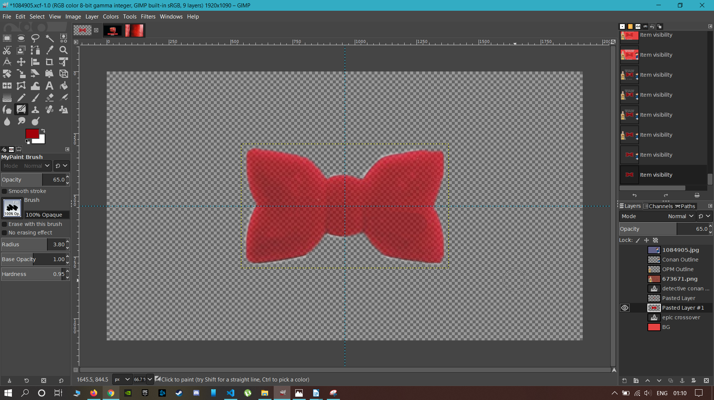Figure 5: Bow Layer

LAYER 6-:
- Again select the File→Open→“Punch_Ref”.
- Switch to the image tab.
- Again using the Scissor Select tool create a selection of the image.
- Copy and Paste the selection to the main workspace tab.
- Select the Floating layer, right-click→“To New Layer”.
- From the Layer Attribute change the Opacity → “75”.
- Using the Scale Tool, scale the selection to desirable size.
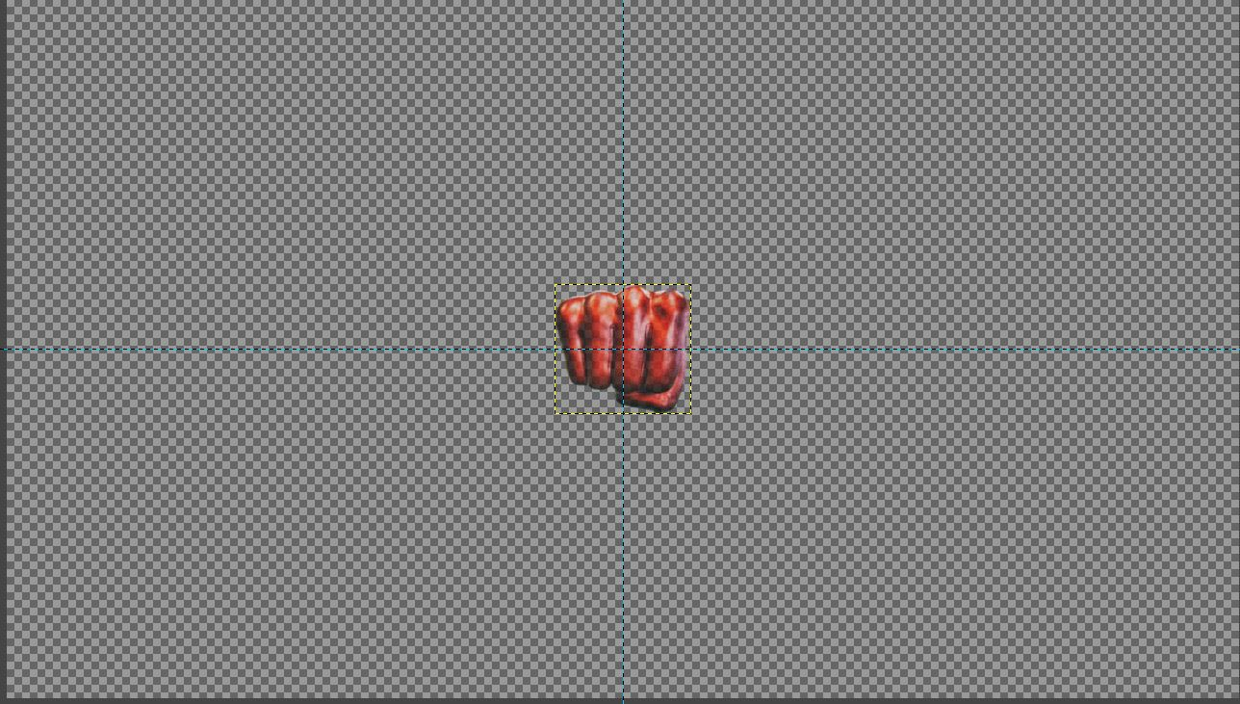Figure 6: Punch Layer

BACKGROUND Layer-:
- Using the Layer Toolbar create another layer to create it as a background.
- Using Bucket Fill Tool to color with light blue (#52bdff).
- Use the gradient tool to apply a gradient of dark gray (#262626).
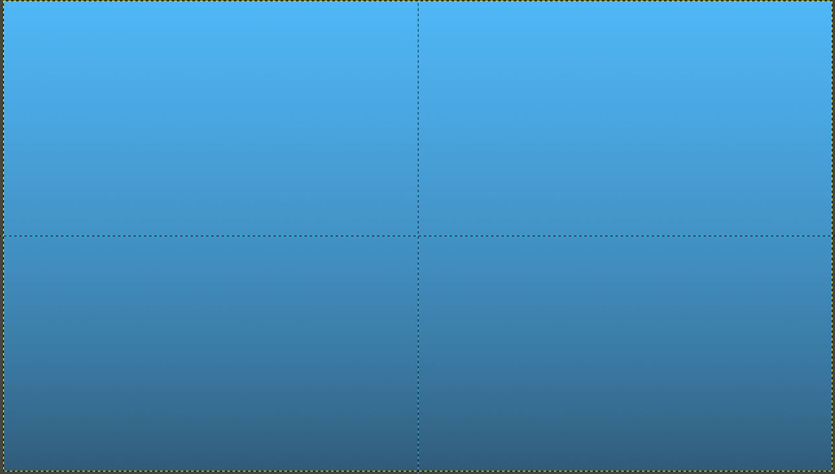Figure 7: Background Layer
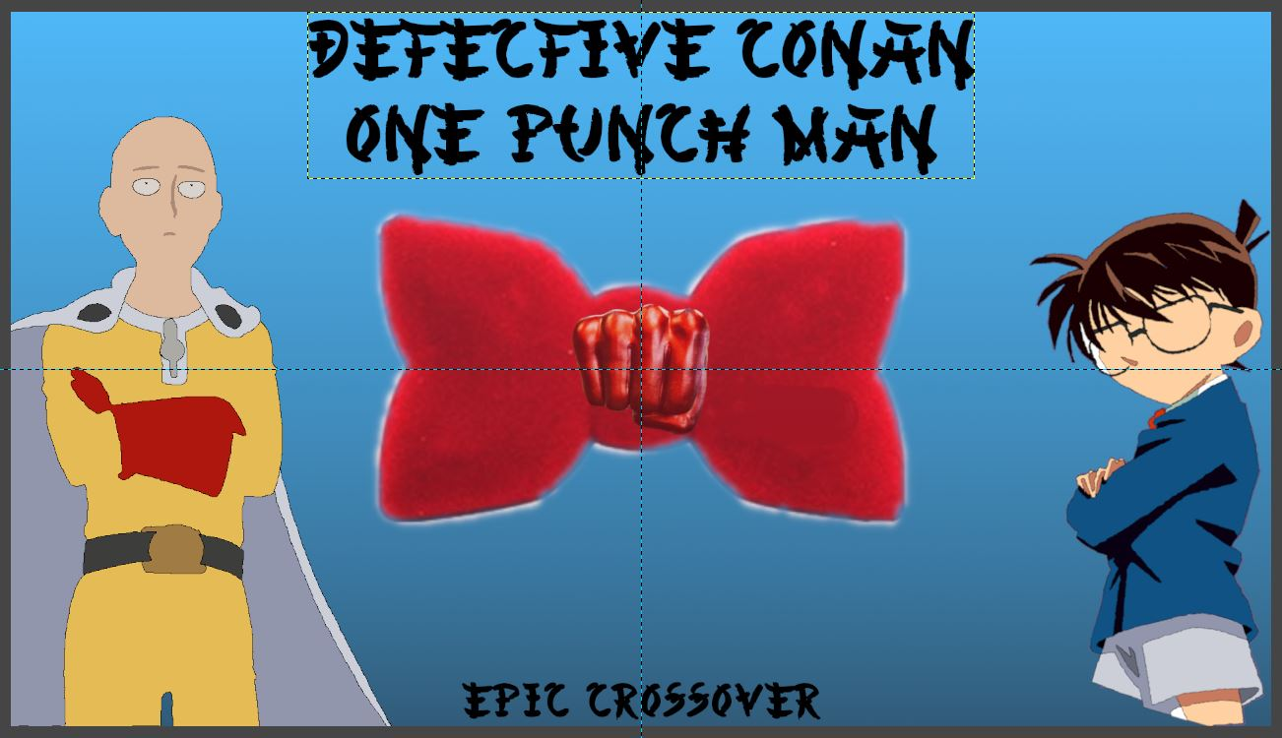Figure 8: Final xcf

Final Poster:-
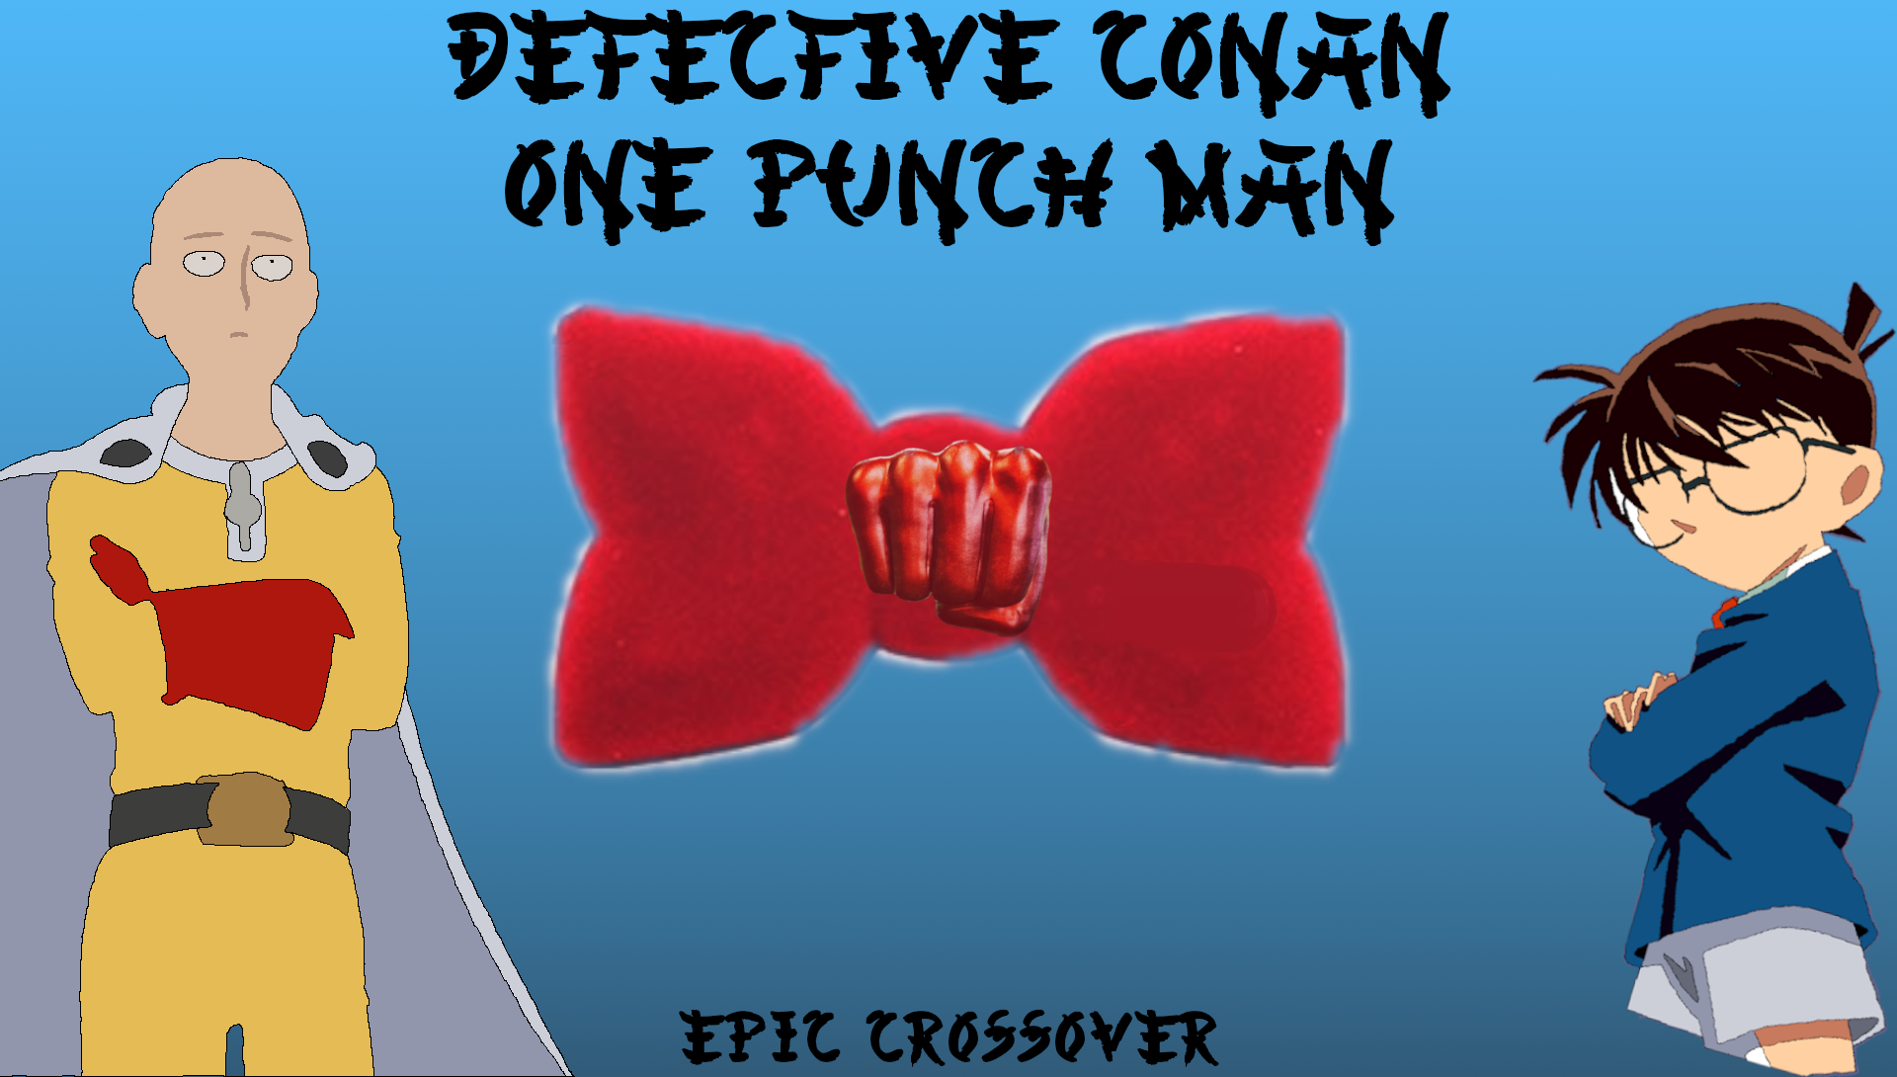Figure 9: Final .png

Explanation for Artistic Choices:-
- Font Choice:- Since the topic is “Anime Cartoon Poster” and the anime characters (anime here referring to the animated cartoon originated from manga, which are Japanese version of what we call comic books, and made specifically in Japan) so, an Asian themed font called Chinese-Asian-Font.
- Font Color:- Background is has a gradient of a light blue (#52bdff) and dark gray (262626).
- Since the first layers with text is there to serve as the display name of the anime series depicted in the work and in-order to make the text flushed with the main logo bow tie, therefore the choice was made to make them bold with the above mentioned kerning, alignment, line spacing, letter spacing, indentation and size values.
- The second layer with a text is kept smaller (70px) in relation to the display name (120px) and bold is off since it serve as the tagline for the poster which is a crossover of two different anime series.
- The color scheme is done in relation to the reference images of the characters used using an online resource to get the hex codes for the colors used in the reference images.
- Since the many punchy, bright colors are used for the characters as they in the reference the choice for the background was made to complement the foreground and blue with hex code #52gdff is used with a dark gray gradient near the bottom to emphasize the character in the bottom right and bottom left.
- Channels R G B with an alpha channel A constitute all the layers in the project. These channels are give layer their body and color. These color channel apply to the whole final image as the three primary colors necessary to render every single color in the project.
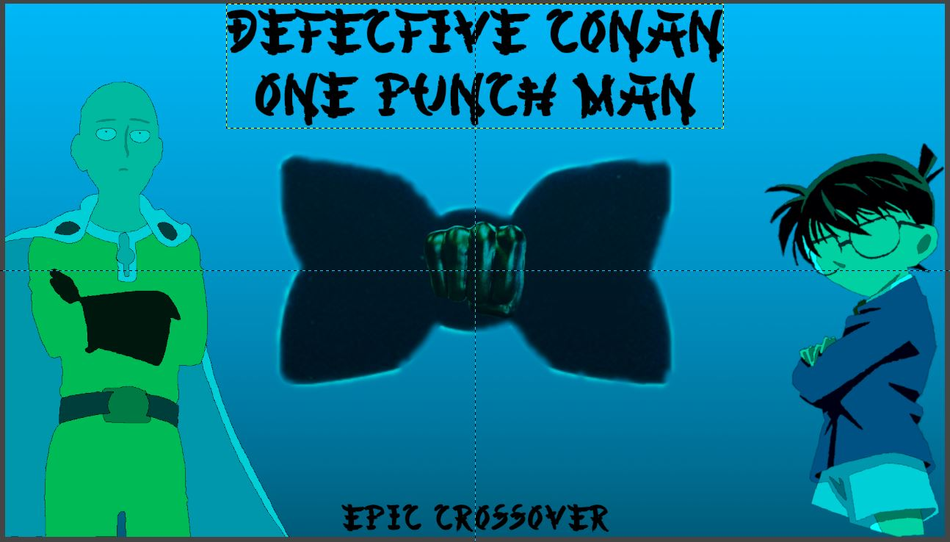Figure 10: Poster without Red Channel
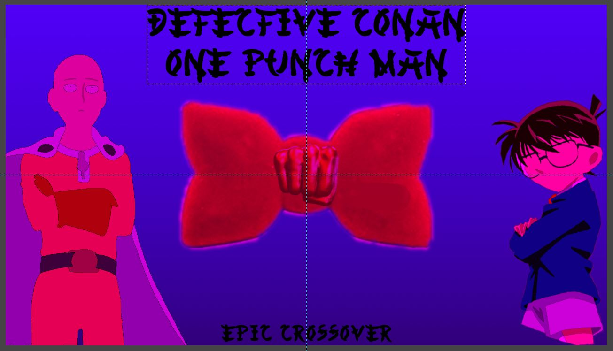Figure 11: Poster without Green Channel
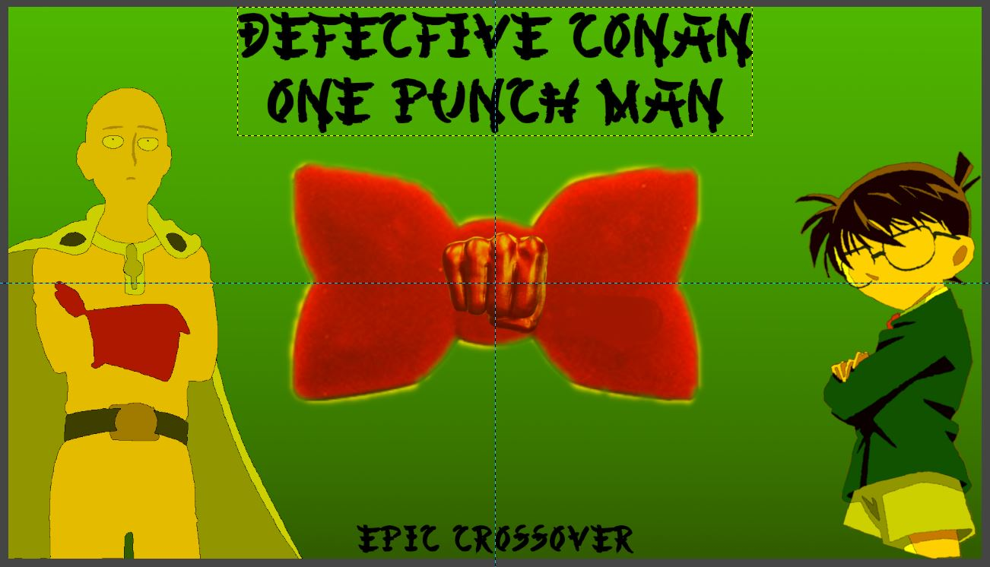Figure 12: Poster without Blue Channel
- So it is clear from the images that colors can’t be represented accurately with having all the three channels on.

References
- Font used:- www.tattoowoo.com/font, created by Jonathan Harris. Copyright © 2012 TattooWoo.com. All Rights Reserved.
- Image Reference 1:- www.zerochan.net
- Image Reference 2:- www.zerochan.net
- Bow Image:- https://images-na.ssl-images-amazon.com/images/I/31jOGkHrWGL._SX355_.jpg
- Punch Image:- www.zerochan.net
- Color codes:- https://pinetools.com/image-color-picker

